**Crime Analysis of UK Using R**

**Group :– 5**

**Group Member :–**

1. **Shreyansh Dange - T194003**
2. **Shubham Chandgude - T194013**
3. **Santanu Choubey - T194097**

**[Synopsis]**

We have taken crime dataset of UK government to visualize the most affected places where the crime had happened. The analysis include various plots which shows the category wise number of crime happened in the locale of UK streets with maximum traceable location over the certain time period. This helps UK police to take necessary action on the places where the crime has occurred in large number which in turns reduce the crime at a prominent level.

**[Reference]**

* https://uk.sagepub.com/en-gb/eur/an-introduction-to-r-for-spatial-analysis-and-mapping/book241031
* https://popcenter.asu.edu/library/reading/pdfs/55stepsUK.pdf
* https://github.com/Robinlovelace/Creating-maps-in-R
* https://data.gov.uk/

**[Problem Definition]**

Analysis of UK crime to reduce the number of crime rate in the streets of UK. This analysis is for the Police Department so that by looking into this analysis they can infer the possibilities of crime in a particular area and take appropriate action as to catch the criminals which makes the criminal free streets.

**[Project Flow]**

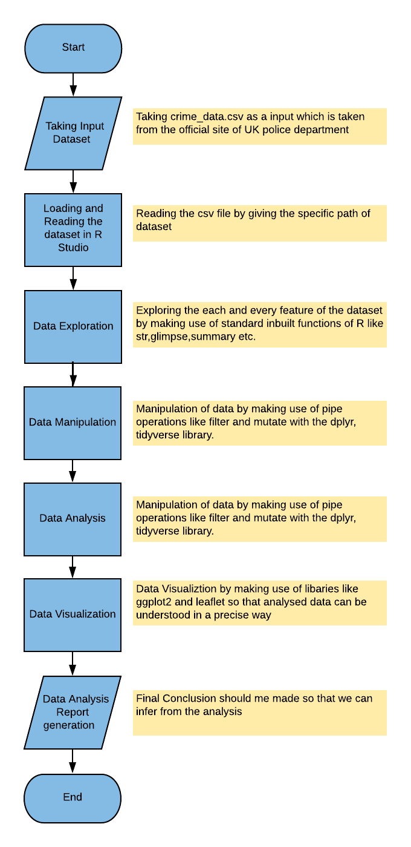

[INPUT DATA]

“Crime_data.csv” which is taken from data.gov.uk. Whole analysis is based on this dataset given by UK government.

[Data Exploration]

* Observations – 221912
* Variables – 7
* Data Types {“date” : Factor, “location” : Factor, “borough” : Factor, “lsoa” : Factor, “category” : Factor, “longitude” : Numeric, “latitude” : Numeric}

[DATA MANIPULATION]

# Frequency of crime by borough (in descending order)

count(crimes, borough, sort = TRUE)

# Frequency of crime category (in descending order)

count(crimes, category, sort = TRUE)

# Frequency and percent of crime category (in descending order)

count(crimes, category, sort = TRUE) %>%

mutate(percent = round(n/sum(n)*100, 1))

# Frequency of crime category by borough (in descending order)

crimes %>%

group_by(category, borough) %>%

summarise(n = n()) %>%

ungroup() %>%

arrange(desc(n))

# Mean frequency of crime category per borough

crimes %>%

group_by(borough, category) %>%

summarise(total = n()) %>%

group_by(category) %>%

summarise(average = round(mean(total, na.rm=TRUE), 0))

# Frequency and percent of Vehicle crime by borough (in descending order)

crimes %>%

filter(category == "Vehicle crime") %>%

group_by(borough) %>%

summarise(n = n()) %>%

ungroup() %>%

arrange(desc(n)) %>%

mutate(percent = round(n/sum(n)*100, 1))

[DATA VISULIZATION]

* Geographical / Web plot for locations where the Robbery happened repeatedly. This is done by leaflet package which helps us to draw plots.
* Pdf Generation for 80-20 rule. The 80-20 % rule is given by Pareto which in this case tells that the only 20% people are responsible for the 80% crime. For this Pdf generation has done using package GridExtra.
* Visualization of Borough level as a proportion of total robbery offences during the time period 12/2015. This visualization is done through waffle charts.
* Crime level in Manchester by month is visualized with help of Heat Map.